

Easter Newsletter March 2018
Edition 1

Welcome to our first edition of our school newsletter which we will be issuing every term. As you can see we have had a busy half term with pupils taking part in lots of extra activities as well as curriculum events. Pupils have written some of these articles so I do hope you enjoy reading them. May I take this opportunity to wish you a Happy Easter and we look forward to seeing the pupils back safe from holiday on Monday April 9th at 9am.

C Mitchell and all the staff

Man City Trip

On Wednesday 7th March I went to the Etihad Stadium to watch Manchester City play Basel FC in the Champions League, with Chadwick High School.
This was a reward trip, so you had to be good to be able to go on the trip.
We went to Manchester in the school minibus, the journey took 1.5 hours and we spent the whole journey on our phones.
When we arrived, we didn’t get checked by security but the adults did. We were sat in the East Stand. They were good seats and we could see everything.
10 minutes into the game City got close to scoring, all you heard was the sound of the seats slamming shut, then they scored and the crowd went mad.
The final score was 2 1 to Basel but Manchester City won on aggregate 5 3, so went through to the next round.
Mr Smith said; ‘What a great experience, both for myself and the students. It is great that the school can offer trips out such as this. Costing students only £10 to watch Manchester City in the Champions League, you cannot complain with that!”

By Alex
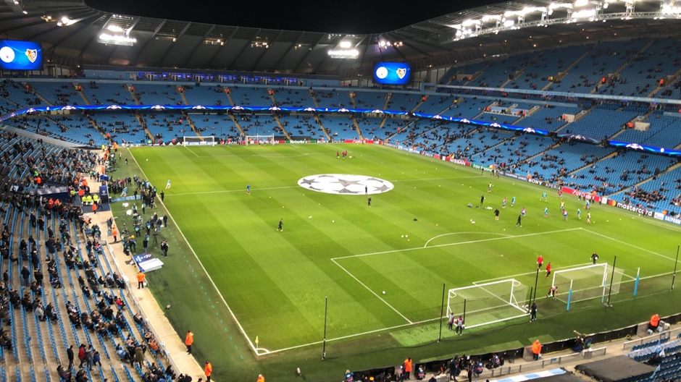

Writing With Mike  On Friday the 9th of March, two teachers and four students from Chadwick High School attended an event at Sandylands Primary School called ‘Literacy Live’ with a guest poet, Rhythmical Mike, who has worked with performers such as Rizzle Kicks and has also made appearances at Glastonbury Festival. The event was aiming to promote a love of literacy in young people.  The first workshop was with Rhythmical Mike himself. The students wrote down three lyrics from three of their chosen songs. In the end they stuck all the lyrics together to form a poem. They then went on to record their poem in Sandylands’ very own recording studio. Rhythmical Mike was very funny and the students and teachers thoroughly enjoyed taking part in his workshop.  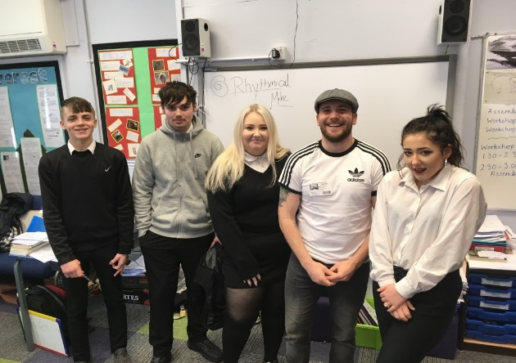  Mrs Mort said that ‘it was fantastic to see the students engaged in creative writing; they really enjoyed the experience and were inspired by Mike, who shared with the students his own struggles with literacy at school. It just goes to show that everybody can be successful writers if they want to be!’  By Danielle |  | GCSE Boxing  Every Friday afternoon, as part of the GCSE PE course, Year 10 students go to Coastal Boxing Club.  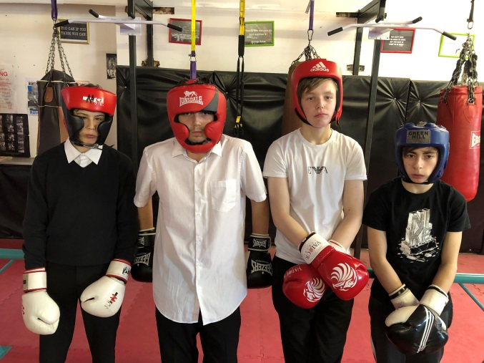  They start off with circuits to develop their fitness, then move on to pad work and finish off with sparring.  The students really enjoy learning new skills and Frank and the staff at the gym are very supportive.  Mr Smith said that: “Frank does a great job providing our students with the boxing extra-curricular activity. It is ideal for the students to improve their fitness and gain self-belief, which is vital for their future progression.”  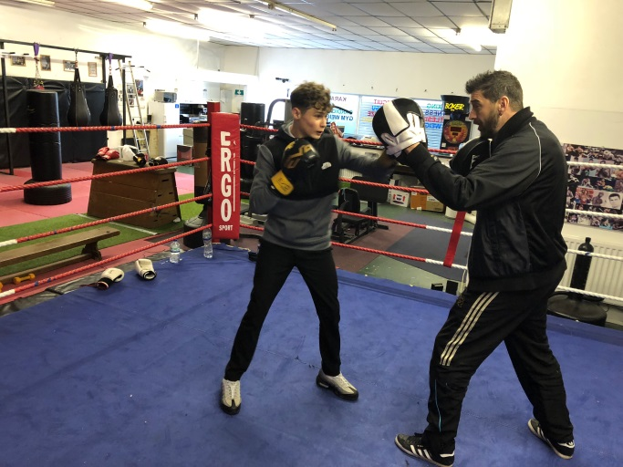

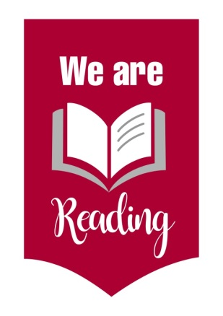
WHY NOT READ?

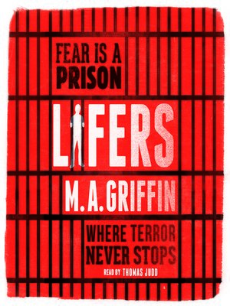
On the 12th of March 2018, multiple primary and secondary schools from Lancashire attended the ‘We Are Reading’ Launch, which is aiming to promote reading amongst young people over Lancashire.
The event took place at the Marriott Hotel in Preston, with students, teachers and headteachers attending from each of the chosen schools. Also attending were: authors Martin Griffin and Jon Mayhew, County Councillor Susie Charlies, Cabinet Member for Children, Young People and Schools, representatives of Lancashire’s Library Service and the Executive Director of Education and Children’s Services, John Readman.

There were workshops and activities with the authors and the opportunity for the younger readers to meet Steve Smallman (an illustrator).
Mrs Mitchell, Chadwick High School headteacher said that:” The ‘We are Reading’ Launch was an exciting afternoon. We were inspired by current children’s writers, had an opportunity to test our creativity by developing a storyline and had professional discussions as to how best to support pupils developing their reading skills. We have lots of plans to develop this in Chadwick, including Breakfast with a Book, developing our school library and writer’s workshops in lessons.”

It was a great opportunity to meet authors and learn about books and how they affect people positively. KS4 students were also given a signed copy of Lifers by Martin Griffin.

By Holly and Hannah

Career Information and Guidance

We have had a busy half term preparing pupils for their post 16 provision.

In January we had the Department of Work and Pensions and the Army visit school to carry out mock interviews with our Year 11 pupils. The feedback they received was very positive and will help them prepare for their actual interviews.

In March we held a careers event for our Year 10 and Year 11 pupils which was attended by local employers and local post 16 providers. This enabled pupils to explore options about their next steps and engage with local industry.

We are working with Inspira to ensure that all of our pupils have appropriate plans in place for when they leave us. We are hoping to organise adult literacy classes and support into work drop in sessions please contact school if you would like more information about this.

Our Key Stage 3 mixed football team
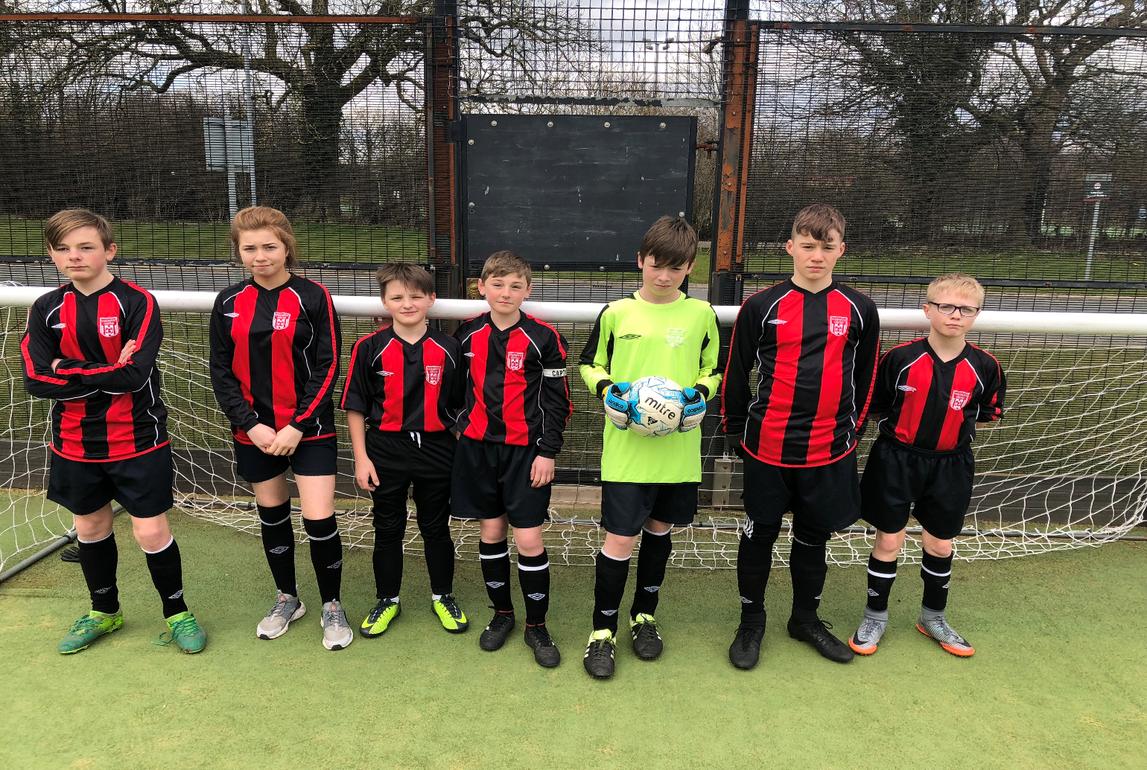

Dates for the diary
Easter – School closes Friday 23rd March 2018 and re-opens Monday 09th April 2018
May Day Bank Holiday Closure – Monday 07th May 2018
Spring Bank Holiday – School closes Thursday 24th May 2018 and re-opens Monday 04th June 2018
Parent’s Summer Extravaganza – Wednesday 18th July 2018
Summer Holiday – School closes Thursday 19th July 2018 and re-opens Tuesday 04th September 2018

 | All the staff at Chadwick High School wish you a safe and Happy Easter

