Mainway, Skerton, Lancaster, LA1 2AY
Tel: 01524 840831
enquiries@chadwick.lancs.sch.uk
www.chadwickhigh.co.uk
16th July 2020.
Dear Parents, Carers and Students,
Arrangements for School Year 2020/21
It has been a very challenging and unusual time for us all since the closure of school back in March 2020.
The expression “unprecedented” has been used so much to describe what has happened that unprecedented has become the new normal. It is with great relief that I can detail our plan for the next academic year, which hopefully brings a semblance of normality back to our daily routines.
Working within the current guidance, I have put together a timetable which will maximise the rooming and staffing available in our school whilst keeping everyone safe.
This will mean that school will be open every day to all students but we will have to change the length of the school day to achieve this.
The school day from Wednesday 2nd September 2020 will be;
Form Time 8:45 Collect Laptops
Lesson 1 9:00
Lesson 2 9:50
Break 10:40 till 11:00 Snacks served
Lesson 3 11:00
Lesson 4 11:50
Form 12:40
End 12:45 Return Laptops
Lunches 12:45 Students can collect lunches to leave with.

We will be continuing to use laptops within lessons as teachers will prepare their lessons on the TEAMS platform, making them available to all students online. Personal laptops are also more hygienic than paper books at this time as they can be cleaned easily.

I hope that you are satisfied with our offer as we have managed to avoid using a rota system or staggered days like many other schools have had to adopt. This is because staff have worked tirelessly to move furniture and mark out rooms as it is important to us that we see our students every day.

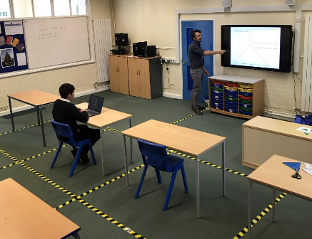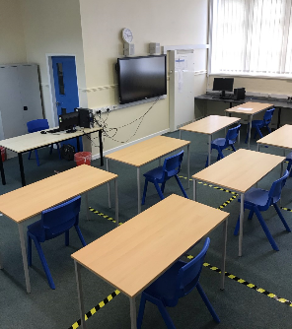
This is an example of how we have set our rooms out to ensure students and staff are at a safe working distance from each other.
The use of laptop ensures every student can see the detail of the lesson without the teacher having to get in their personal space, thus minimising the chance of close contact cross contamination.
In the event of an outbreak or symptoms
*** If your child has any symptoms of feeling unwell please do not send them to school***
The impact that a student with a positive covid 19 test would have on the school is catastrophic as we are all in the same bubble.
If a child is identified as having symptoms whilst in school.
- Student is immediately isolated and parents requested to collect immediately.
- The student cannot return to school until a Covid 19 test has been undertaken and the result must be shared with the school within 48 hours.
- ·If the Covid 19 test is positive then the whole school will close for 2 days from the time we are informed and every person must undergo a Covid 19 test.
- Only those that can then show a negative result will be allowed to return to school.
- Anyone testing positive must self isolate at home for 14 days from point of testing.
As you can see an unwell child sent to school will cause an enormous danger and inconvenience to every single person in the school community.
Students who pretend to have symptoms will be treated exactly the same as those who have them for real, we cannot test students, only the NHS can do that. It might be worth sharing with your child what the Covid test actually involves to prevent anyone crying wolf.
Our school code of conduct has been amended to manage behaviours which are unacceptable in these C19 times. This includes coughing at others, pretending to have C19, deliberately touching people etc. We all have a responsibility and a duty of care towards each other and regardless of your own personal view points we need to respect the rights of all people to feel safe in school.
The wearing of masks is not required in school although all students travelling on public transport will need a mask. This is not the responsibility of the school to provide masks.

Holidays Abroad
If you are planning a holiday to a country which is not on the safe destination list ie USA or Portugal please inform the school. Your child will not be able to attend school until 14 days after your return to the UK.
School Website
I would advise that you regularly check the school website for updates throughout the summer as our office is closed and this is the only form of communication open to us.
I hope you all have a restful break time and I look forward to seeing everyone in September for what I hope is a far less eventful year.
Kind regards
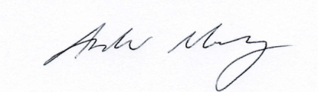

Andrew Murray
Headteacher

School Term Dates 2020/21
Autumn Term
Half Term 1 Wednesday 2nd September – Wednesday 21st October 2020 (36 openings)
Half Term Thursday 22nd October - Friday 30th October 2020
Half Term 2 Monday 2nd November - Friday 18th December 2020 (35 Openings)
Spring Term
Half Term 3 Monday 4th January - Friday 12th February 2021 (30 Openings)
Half Term Monday 15th February - Friday 19th February 2021
Half Term 4 Monday 22nd February - Friday 26th March 2021 (25 Openings)
Summer Term
Half Term 5 Monday 12th April - Friday 28th May 2021 (34 Openings)
Bank Holiday Monday 3rd May 2021
Half Term Monday 31st May - Friday 4th June 2021
Half Term 6 Monday 7th June - Friday16th July 2021 (30 Openings)
Total school days is 190

