Chadwick High
Catch Up Funding Report
Following the guidance outlined by the EFF (Education Endowment Foundation) Chadwick High has used the additional funding to support our initiatives in ensuring a high quality provision for all of our students.
Working within the guidance set out in;
THE EEF GUIDE TO SUPPORTING SCHOOL PLANNING: A TIERED APPROACH TO 2021
We have created our plan for delivering our curriculum by identifying specific strategies in;
- Teaching
- Targeted Academic Support
- Developing Wider Strategies
Teaching
The provision of high quality teaching is at the heart of improving student outcomes therefore a priority for Chadwick has been to ensure that all lessons are delivered by specialist teachers, not just some. We have therefore adapted the timetable to ensure that adequate time has been allocated to planning the online lessons.
To compliment high quality teaching we need high quality assessment which is why a priority has been the development of a toolkit to ensure that we continue to monitor the quality of our teaching and learning.
Targeted Academic Approach
A highly personalised approach to working with each student has been developed building a strong working relationship between Teacher → Student → Key worker → Parent. We have strengthened the relationships through greater communication and creating blended learning experiences for students when needed. Students can work in groups or have bespoke 1:1 sessions with teachers and key workers, this can be online or in school as we have ensured that all of our students have access to our site.
Developing Wider Strategies
All of our students have barriers to learning and these have been exasperated by Covid 19. The main concerns for us as a school have been access to IT, attendance, school meals and safeguarding of the most vulnerable.

Costings
Cost Centre | Detail | Cost
Teaching | CPD - Development of Remote Learning Platform  Resources - Provision of Laptops for Teachers  Assessment – within remit of existing staffing  Increased PPA – Timetabling exercise  Reducing workload (see class size)  Well Being – within existing offer | £1,700  £5,010  £0  £0  £0  £0
Targeted Academic Support | Class Size - Maintaining small group size  Well being - Ensuring Key Worker Provision.  Access For All – timetabling exercise  Website – within remit of existing staffing | £0  £0  £0  £0
Wider Strategies | Digital Poverty - Laptop and WIFI provision for all students  Welfare of students - School Meals (free to any student attending)  Safeguarding – within remit of existing staffing.  Attendance and Engagement – within remit of existing staffing. | £  £  £0  £0
 | Additional Cost to School
Catch Up Funding | Based on 63 students @ £240 per student | £15,300

Analysis of Costs
Much of what provide as a school to support our strategies can be met within our existing budget and resources.
Additional costs have arisen in ensuring equality of provision and access. Digital poverty is the single biggest challenge and even though we received 27 DFE laptops, almost every single student in our setting did not have access to a laptop at home.

EEF GUIDE TO SUPPORTING SCHOOL PLANNING (2020-21) – TIERED MODEL
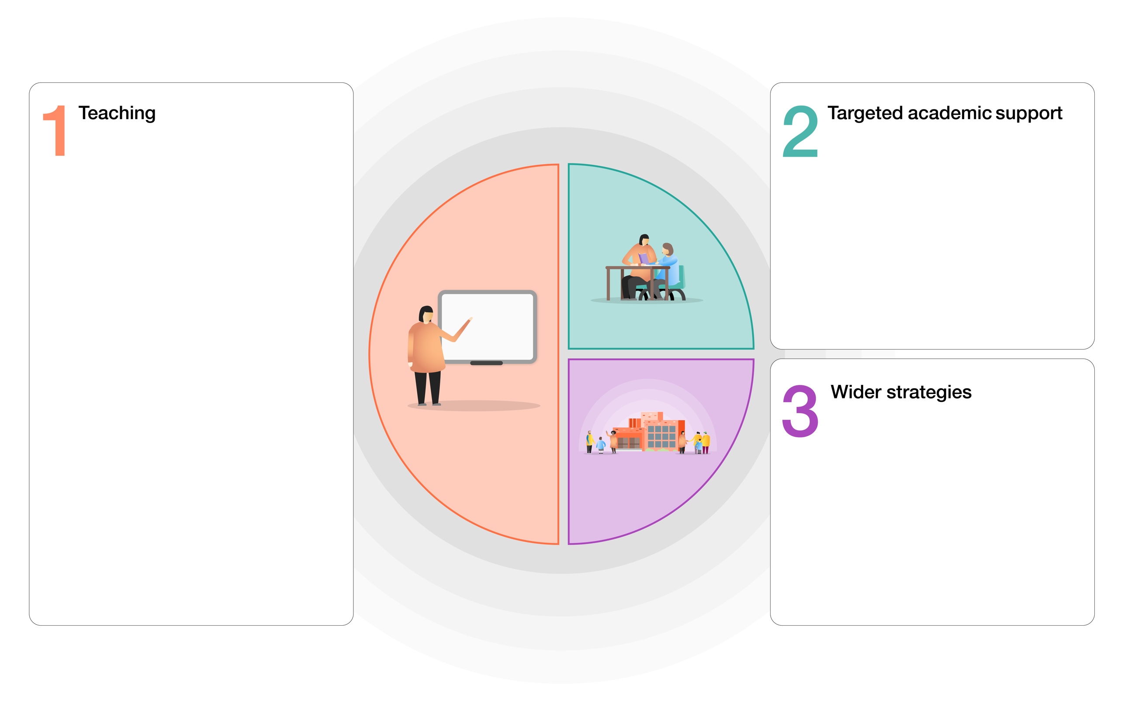
Staff CPD
Training on TEAMS platform as groups and individuals.
Assessment
Working with staff to develop high quality assessment to support CAG and ensure students continue to make progress.
Reducing Workload
Reducing number of lessons taught by each subject teacher
Increased PPA
To support teachers in re designing lessons for remote platform the amount of PPA has been increased by reducing staff meetings.
Resources
Ensuring every teacher has Laptop and other IT equipment (visualisers, software) to deliver high quality remote learning experiences.
Well Being
Increasing scope of our Well Being programme to ensure that all staff understand what is available to them and how to access it

Digital Poverty
Ensuring every student has their own laptop to access at home and that they have wifi.
Attendance and Engagement
Additional rigour in chasing attendance and engagement
School Meals
Providing free meals to all students on site and ensuring that students receive school vouchers at earliest point.
Safeguarding
Additional rigour in safeguarding eg action on non attendance reduced from 3 to 2 days. Daily welfare calls to all students
Class Size
Keeping class sizes to max of 8 per lesson. Offering breakout rooms for 1:1 support with Learning Support within lessons.
Access for All
No restrictions on what students can access school
Website – Additional materials
All lessons and additional learning materials available on our web site – secure area.
Key Workers
Every student has key worker making daily welfare calls

