Joint museums and bus ticket offers summer campaign

Cheap days out by bus
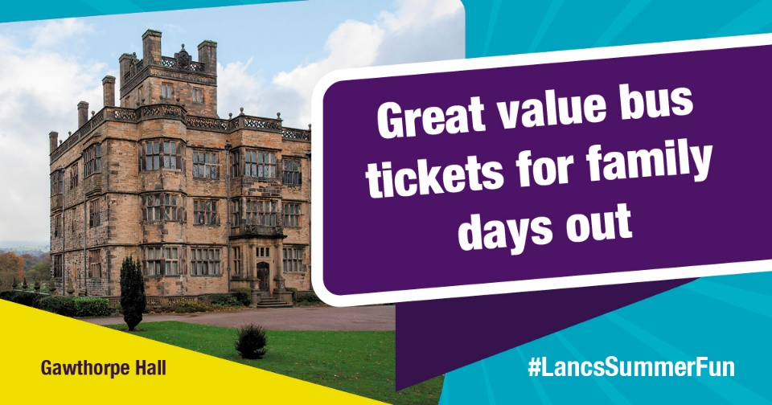

Why not take advantage of our cheap bus offers to visit Lancashire's museums this summer.
There are some great offers on bus tickets running, it’s a maximum of £2 for single journeys every day on most bus services. Also with the new weekender ticket, you can buy a day ticket on the bus on a Saturday for free travel on Sunday. Kids under 5 always travel free.
With 6 county council museums to explore across Lancashire, there's lots of options for days out to keep the kids entertained in the summer holidays and beyond. There's plenty of exciting activities at our museums this summer, with most open through to October half term.
Find out more about our bus ticket offers and the different museums you can visit at – www.lancashire.gov.uk/publictransport
The fare offers are funded by government as part of the council's Bus Service Improvement Plan.

