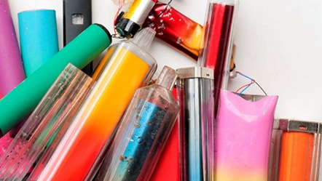

Vape warning after teenagers taken ill
Parents are being warned of the dangers of unregulated vapes after several young people were taken ill in Lancaster and Morecambe.
In recent weeks Lancashire Police has received reports of five teenagers, all students at local schools and colleges, having fallen ill and required hospital treatment after smoking contaminated vapes.
Officers believe the vapes could contain dangerous Class B drugs, including amphetamine and THC.
An investigation into the circumstances around the incidents is underway and enquiries ongoing. At this time no arrests have been made.
Supt Craig Kelshaw, of place-based superintendent for Lancaster, Morecambe, Fylde and Wyre Police, said: “We are urging parents to be vigilant after a number of young people were taken ill after smoking vapes believed to contain illegal drugs.
“In recent weeks, police have become aware of several incidents across Lancaster and Morecambe, with students at some schools and colleges taken ill and requiring hospital treatment.
“The legal age to use and purchase vapes is 18, however, we know that they are being sold to young people via social media, and these are then being taken into schools and colleges.
“Not only is this a health issue, but those possessing and supplying illegal drugs could be committing criminal offences. We are working closely with local schools and partners to share information and intelligence.
“We would also urge parents, guardians and anyone with information they may have about those supplying these vapes to call Lancashire Police on 101.”
Cllr Michael Green, Lancashire County Council's cabinet member for Health and Wellbeing, said: "We are very concerned about the latest spate of young people becoming ill after using vapes believed to have contained illegal drugs across Lancashire.
“We know that our young people are obtaining these substances often via social media and using them in school settings.
"Vaping illegal and unknown substances carries significant health risks including becoming immediately unwell, loss of consciousness and even risk to life and we urge everyone to do their utmost to be vigilant and aware of the very significant dangers.
"If you are concerned about a young person using drugs and vapes, please contact specialist support charity We are With You' via their website or on 0808 164 0074.
"We have also responded to the Government consultation in support of stronger national action to address the unscrupulous marketing of vapes that are targeted at our young people."
Anyone with information about the supply or use of these illegal vapes should contact Lancashire Police on 101 or Crimestoppers anonymously online at www.crimestoppers-uk.org or by calling 0800 555 111.

