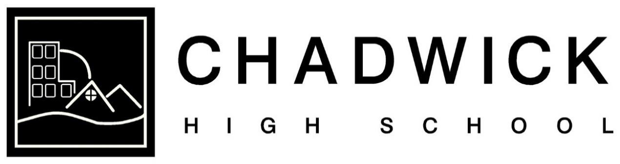

Freedom of Information Policy

September 2021
Next Review: September 2024

About this policy

1.1 This policy outlines Chadwick High School’s approach to requests made under the Freedom of Information Act 2000 (FOIA).

1.2 The School complies with the provisions of the FOIA which allows any member of the public to request information from public bodies.

Who is responsible for this policy

2.1 The School has overall responsibility for the effective operation of this policy and for ensuring compliance with the relevant statutory framework for freedom of information.

2.2 The School has delegated day-to-day responsibility for operating the policy and ensuring its maintenance and review to the School’s Data Protection Officer, their contact details are:

Data Protection Officer
Chadwick High School
Mainway
Lancaster
LA1 2AY
Email: dpo@chadwick.lancs.sch.uk
Phone: 01524 840831

Publication scheme

3.1 The School understands its duties under the FOIA to be transparent and proactive in relation to the information that it makes public.

Requests

4.1 The FOIA applies to all recorded information held by the School, along with information held by a third party organisation on behalf of the School.

4.2 Any member of staff that receives a Freedom of Information request (or believes that they may have done so) should forward it without delay to the school’s Data Protection Officer. The school has a statutory timeframe to adhere to which is 20 working days, and failure to promptly report a Freedom of Information request (or a request believed to be a Freedom of Information request) may lead to disciplinary action.

4.3 The School will provide a response to a Freedom of Information request within 20 working days unless the data subject is notified that the statutory timeframe is extended by a necessity to consider the public interest test.

Advice and assistance

5.1 The School will provide advice and assistance to requesters in accordance with Section 16 of the FOIA.

Internal review

6.1 The School operates an internal review procedure for any requester that is dissatisfied with the handling of their Freedom of Information request. Internal reviews will be carried out by a senior member of School staff or Governor who has not been involved in making the original decision or responding to the request.

6.2 As part of the School’s internal review procedure, the Management
Committee will consider whether or not the request was handled appropriately and in accordance with the requirements of the FOIA.

6.3 Requesters seeking an internal review must write to the School’s Data Protection Officer within 40 working days of the date of the school’s response to the original request stating the grounds for the review.

6.4 The School will endeavour to respond to requests for internal review within 20 calendar days of receipt of the request. Where this is not possible, the School will write to the requester to inform them of the expected date of response to their request for internal review.

6.5 Some information requested may be subject to an exemption under the FOIA. In the event that it is, the School will set out the exemption and sufficient information as to why the exemption applies.

6.6 Requesters who are unhappy with the outcome of the internal review may raise a complaint with the ICO.

6.7 For further information on FOIA requests, exemptions and duties that apply under the legislation please see the guidance maintained on the Information Commissioner’s website: Guide to freedom of information | ICO

