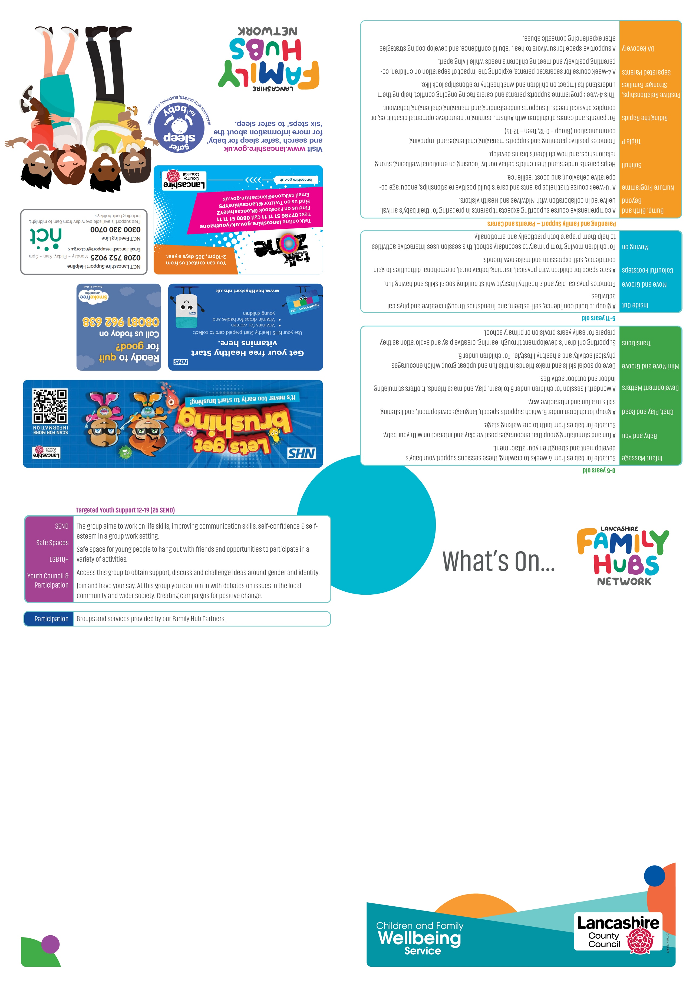

October – December 2025

Targeted Youth Support 12-19 years old up to 25 years with SEND

Monday – **SEND EASY group** for 12-25 year olds. A youth group for young people with SEND Morecambe Library 6:15-8:30pm Contact Claire Armer 0771815062 for a place.

Tuesday- **PYRO** Contact Nicole Cobb 01524 581280

Wednesday- **Youth Council** – 6:15-8:30pm- White Cross- Contact Nicole Cobb 01524 581280.

Thursday- **Detached Morecambe**- Contact Charlie Bluglass 07977273886

**Prop Up Group** for people struggling with emotional and mental health Morecambe Library/Rainbow Centre- Contact Claire Armer 07717815062

Friday- **Safe Space youth group** for young people aged 12- 19 to 25 with SEND Contact Claire Armer 07717815062

**Detached City Centre & North Lancaster**- Contact Nicole Cobb 01524 581280

Lune Park Family Hub, LA1 2LN

Morecambe Central Hub, LA4 5DL

Carnforth Family Hub, LA5 9LS

Westgate Neighbourhood Centre, LA4 4XF

Family Hub Number – 01524 581280

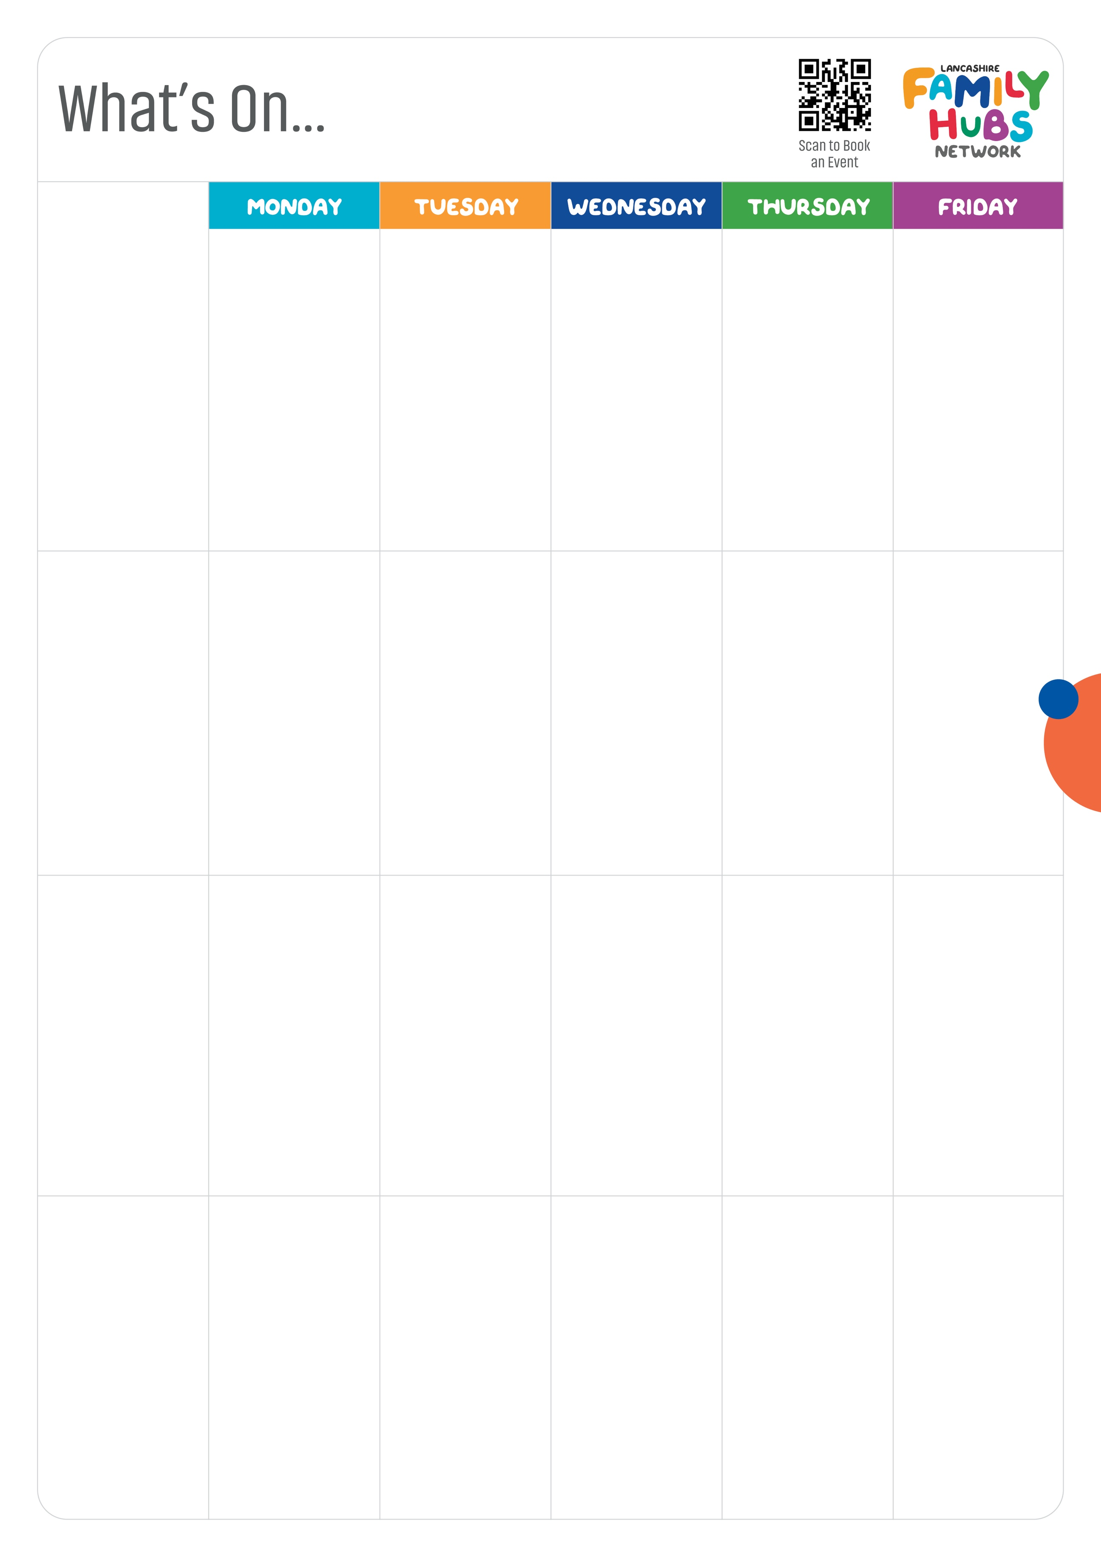

**Triple P Group at Carnforth (Pre-book)**

9.30-11.30am

**The Listening Lounge at Carnforth**

9.30 – 11.30am (1st Monday every month)

**Babbling Babies at Carnforth (0-18 months)**

1.00-2.00pm

**School's Out at Carnforth**

3.30-4.30pm

**Are you in an abusive relationship or have you been affected by domestic abuse?**



Call 01524 581280 for more information about the DA Recovery Programmes.

**Baby & You (0-pre walking)**

10.00-11.00am

**For information about the groups and ages range please check the other side of this guide.**

**Other venues:**

**Carnforth**

LA5 9LS

**Sandylands**

LA3 1EJ

**Salt Ayre Leisure Centre**

LA1 5JS

**Food Club at Carnforth**

2.00-4.00pm



**Ready,Steady, Go!** **Salt Ayre Leisure Centre** 1pm-3pm starting Thursday 6th November.

**Coffee & Connect at Morecambe Central**

9.30-11.30am (1st Thurs of the month)

**Baby & You**

1.00-2.00pm

**Triple P Group (Pre-book)**

9.30-11.30am

**Colourful Footsteps (0-8 years)**

1.00-2.30pm

**Bump, Birth & Beyond (Pre-book)**

5.30-7.30pm

**Early Explorers at Sandylands Community Hub**

9.15-10.15am

Ask at your local Family Hub about Healthy Start

**Development Matters**

9.30-11.30am

**Babbling Babies (0-18 months)**

1.00-2.00pm

**New Horizons (Pre-book)**

9.30am-2.30pm

**Chat, Play & Read with Welcomm**

9.30-11.00am

**Infant Massage (Pre-book)**

1.00-2.00pm

**Bump, Birth & Beyond (Pre-book)**

5.30-7.30pm

**Healthy Relationships, Separated Families (Pre-book)**

9.30-11.00am

**Baby & You**

10.00-11.00am

**Westgate**

Langridge Way

Morecambe

LA4 4XF

Ask at your local Family Hub about Funded Childcare Places

**Young Parents to Be at Morecambe Central**

1.00-3.00pm

**Development Matters**

9.30-11.00am

**Infant Massage (Pre-book)**

1.00-2.00pm

**School's Out at Morecambe Central**

3.30-4.45pm

**Morecambe Central**

(Library) LA4 5DL

**Some of these groups have moved from Poulton**

***Lancaster Children &   
Family Wellbeing Service***

*October - December 2025*

**Mini Move & Groove**

9.30-11.00am

**SEND Support Group**

1.00-3.00pm (1st Friday of the month) Starts October

**Infant Massage (Pre-book)**

10.00-11.00am

**Infant Massage (Pre-book)**

11am-12pm

**Chat, Play & Read**

1.00-2.30pm

**Development Matters**

9.45-11.15am



Please call 01524 581280 to book an appointment

**Lune Park**

Ryeland's Park

Owen Road

Lancaster

LA1 2LN